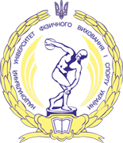
REPORT No. 1

on the progress of project implementation
"Remote functional assessment: innovative solution for rehabilitation of war victims in Ukraine" (No. 2023-K-063) in the National University of Ukraine on Physical Education and Sport

Reporting period – 21.11.2023 - 29.02.2024

- Within the framework of the project, a Partnership Agreement was signed between Lithuanian Sports University and the National University of Ukraine on Physical Education and Sports.
- The Modified Mayo Wrist Score and Mayo Elbow Score scales were translated from English to Ukrainian.
- Canadian Occupational Performance Measure (COMP) was translated from English to Ukrainian and from Ukrainian to English.
- The instruction/manual to use of COMP for rehab specialists in Ukraine was translated from English to Ukrainian.

